4/16/2026
Profit Center Creation UPL
Prepared By Manch Technology



Version History
VERSION | APPROVED BY | REVISION DATE | DESCRIPTION OF CHANGE | AUTHOR
1.0 |  | 16-04-2026 | Profit Center Creation | Aniruddha Rajpurohit

TABLE OF CONTENTS
1. Executive Summary 3
1.1 Purpose 3
1.2 Audience 3
2. Project Description 3
2.1 Background 3
2.2 Objectives 3
3. Project Scope 4
3.1 In Scope 4
3.2 Out of Scope 4
4. Vendor Creation Functional Requirements 5
4.1 Flow Chart 5
4.2 Manch Terminology Reference 6
4.3 Initiation Methods 7
4.4 Field-Level Information 7
4.5 Process Details 29
4.5.1 Initiator Behaviour 29
4.5.2 Vendor Behaviour 30
4.5.3 Approver Behaviour 44
4.5.3.1 Approver Flow 45
4.5.3.2 Specific Approver Behaviour for Contributors 46
4.6 Reference Tables 50
4.7 Record List View 51
4.8 Communication Requirements 51
4.8.1 Communication Channels 51
4.8.2 Communication Templates 51
4.9 Access Management 53
4.10 Reporting Requirements 53
4.11 Integration Requirements 53
4.11.1 Integration Overview 53
4.11.2 Field-Level Mapping and Logic 53
4.11.3 Data Flow and Synchronization 54
4.11.4 Error Handling and Logging 54
4.11.5 API Documentations and other information 54
5. Assumptions 54
6. Appendix 55

1. Executive Summary

1.1 Purpose
The purpose of this document is to describe the data governance strategy that UPL will implement to govern and manage Profit Center master data. It outlines the "To-Be" process flow for creation, ensuring that all standard governance and active governance rules are followed during the implementation of the master data solution.

1.2 Audience
The strategy was developed based on inputs from key stakeholders of the Finance master data team across eight global regions: EUROPE, MECA, AFRICA, NAM, APAC, BRAZIL, LATAM, and INDIA. The document serves as a guide for:
Business Process Owners and Initiators (Country/Regional teams).
Approvers, including Regional Finance Heads, Platform/Business Units, FP&A teams, and SAP RTR & MDM teams.
Technical Implementation Partners (SI) responsible for building and integrating the solution with SAP S/4HANA

2. Project Description

2.1 Background
UPL Limited is a multinational provider of sustainable agricultural solutions with annual revenue exceeding US$6 billion. To support its global operations, UPL requires a standardized Master Data Governance (MDG) solution for its Finance master data. The project involves integrating the Manch platform with UPL's SAP S/4HANA environment (including India MFG, India SAS, and International Crop Protection instances) via the SAP BTP Cloud Connector.

2.2 Objectives
The primary objectives for the Profit Center creation process are:
- Active Governance: Implementing a platform to serve as an ongoing management tool for creating Profit Centers with enforced standard and custom business validations.
- Data Reliability: Ensuring reliability and accuracy in reporting, which is critical for effective executive decision-making.
- Standardized Workflow: Establishing a multi-step global approval process from initial request through Regional Finance, Business Unit, and FP&A reviews to final MDM team approval.
- Automated Integration: Enabling real-time, automated creation of Profit Center codes across SAP servers (INP, MFG, and MKP) once final approval is granted.
- Quality Control: Utilizing duplication logic (e.g., checking "Long Text" fields with a 95% threshold) to prevent redundant master data.

3. Project Scope:

3.1 In Scope:
MDM platform will serve as an ongoing management and governance tool for creating, changing, extending, and blocking/unblocking Finance Master Data. SI will ensure adherence to all standard governance processes and active governance rules mentioned in this document. It will also enforce standard and custom business validations prior to processing any master data in the SAP S/4HANA system.

3.2 Out of Scope: Not Applicable

4. Profit Center Creation Functional Requirements

4.1 Flow Chart:
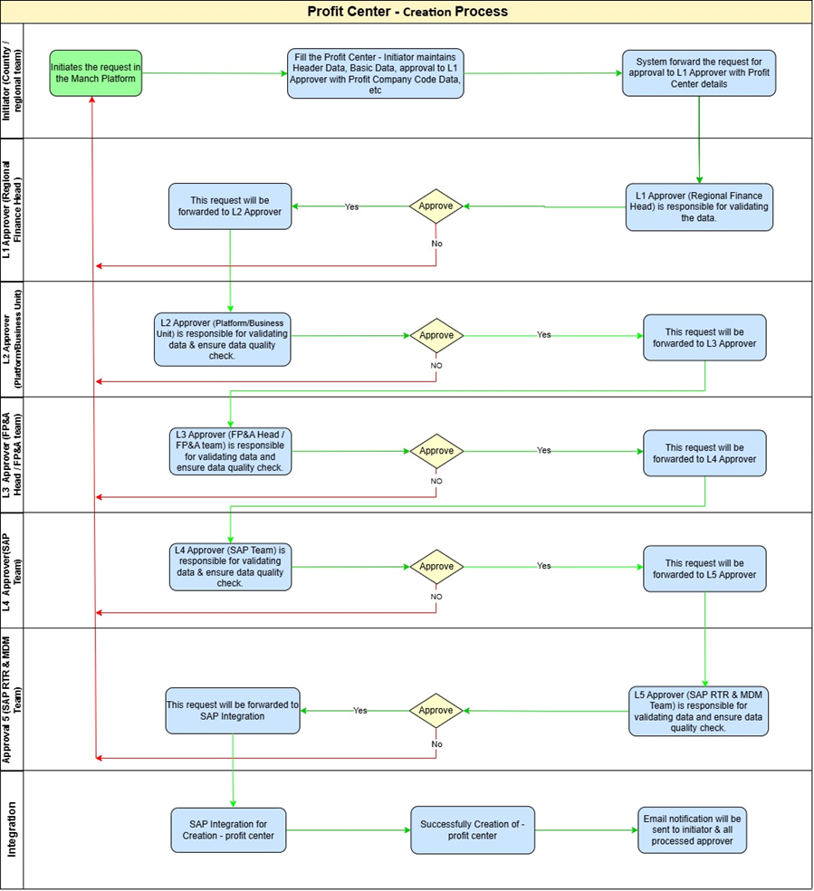

4.2 Manch Terminology Reference
BUD Terminology | Manch Terminology
Requestor / Initiator Behaviour | First Party Behaviour
Approver / Contributor Behaviour | Approver or Template Participants Behaviour

4.3 Initiation Methods
• Initiates the request in the Manch Platform.
• Fills the Profit Center request form, where the initiator maintains the required
details such as Header Data, Basic Data, Company Code Data, etc

4.4 Field-Level Information
Below are the details of each field used in this process, with the common logic for all stakeholders in the process.

Field Name | Field Type | Mandatory | Logic and Rules other than common logic
Header Data | PANEL
Profit Center | TEXT | YES | It requires alphanumeric text input with a maximum limit of 10 characters (CHAR).
Controlling Area | TEXT | YES | The default value '1000 -- UPL Group' will be auto-populated.
Validity Period From | DATE | YES | It requires an 8-character valid date format (DATS, e.g., YYYYMMDD).
Validity Period To | DATE | YES | The default value '31.12.9999' will be auto-populated, but remains editable. It requires an 8-character valid date format (DATS, e.g., YYYYMMDD).
Basic Data | PANEL
Status | TEXT | YES | The default value ("A- Code" "Active - Values") will be auto-populated.
Name | TEXT | YES | It requires alphanumeric text input with a maximum limit of 20 characters (CHAR).
Long Text | TEXT | No | It requires alphanumeric text input with a maximum limit of 40 characters (CHAR).
User Responsible | DROPDOWN | No | It renders as a dropdown for the Initiator; input must be selected from EDV the reference table “User Responsible” refer column 1
Person Respons. | TEXT | YES | It requires alphanumeric text input with a maximum limit of 20 characters (CHAR).
Department | TEXT | No | It requires alphanumeric text input with a maximum limit of 12 characters (CHAR).
Profit Ctr Group | DROPDOWN | YES | It renders as a dropdown for the Initiator; input must be selected from EDV the reference table “Profit Control Group” refer column 1
Segment | DROPDOWN | No | It renders as a dropdown for the Initiator; input must be selected from EDV the reference table “Segment” refer column 1
Indicator | PANEL
Lock indicator | CHECKBOX | No | It functions as a single-character checkbox indicator (CHAR 1).
Template for Formula Planning in Profit Centers | DROPDOWN | No | It renders as a dropdown for the Initiator; input must be selected from the EDV.  Sheet unavailable.
Company Code | PANEL
Company Code | DROPDOWN | YES | Dropdown values are column 1 and column 2 of EDV `COMPANY_CODE`.
Company Name | TEXT | No | It requires alphanumeric text input with a maximum limit of 25 characters (CHAR).
Assigned | DATE | No | It functions as a checkbox indicator (1 character limit, CHAR).
Address Data | PANEL
Country/Region Key | DROPDOWN | No | It renders as a dropdown for the Initiator; input must be selected from EDV the reference table “Country Region Key” refer column 1
Title | TEXT | No | It requires alphanumeric text input with a maximum limit of 15 characters (CHAR).
Name 1 | TEXT | No | It requires alphanumeric text input with a maximum limit of 35 characters (CHAR).
Name 2 | TEXT | No | It requires alphanumeric text input with a maximum limit of 35 characters (CHAR).
Name 3 | TEXT | No | It requires alphanumeric text input with a maximum limit of 35 characters (CHAR).
Name 4 | TEXT | No | It requires alphanumeric text input with a maximum limit of 35 characters (CHAR).
City | TEXT | No | It requires alphanumeric text input with a maximum limit of 35 characters (CHAR).
District | TEXT | No | It requires alphanumeric text input with a maximum limit of 35 characters (CHAR).
Street and House Number | TEXT | No | It requires alphanumeric text input with a maximum limit of 35 characters (CHAR).
PO Box | TEXT | No | It requires alphanumeric text input with a maximum limit of 10 characters (CHAR).
Postal Code | TEXT | No | It requires alphanumeric text input with a maximum limit of 10 characters (CHAR).
P.O. Box Postal Code | TEXT | No | It requires alphanumeric text input with a maximum limit of 10 characters (CHAR).
Region | DROPDOWN | No | It renders as a dropdown for the Initiator; input must be selected from EDV the reference table “Region” refer column 1
Tax Jurisdiction | DROPDOWN | No | It renders as a dropdown for the Initiator; input must be selected from EDV the reference table “Tax Jurisdiction” refer column 1
Communication | PANEL
Language Key | DROPDOWN | No | The default value 'Yes' will be auto-populated.
Telebox Number | TEXT | No | It requires alphanumeric text input with a maximum limit of 15 characters (CHAR).
First telephone number | TEXT | No | It requires alphanumeric text input with a maximum limit of 16 characters (CHAR).
Second telephone number | TEXT | No | It requires alphanumeric text input with a maximum limit of 16 characters (CHAR).
Fax Number | TEXT | No | It requires alphanumeric text input with a maximum limit of 31 characters (CHAR).
Teletex Number | TEXT | No | It requires alphanumeric text input with a maximum limit of 30 characters (CHAR).
Telex Number | TEXT | No | It requires alphanumeric text input with a maximum limit of 30 characters (CHAR).
Data communication line no. | TEXT | No | It requires alphanumeric text input with a maximum limit of 14 characters (CHAR).
Printer name for profit center | TEXT | No | It requires alphanumeric text input with a maximum limit of 4 characters (CHAR).
Deletion flag | PANEL
Mark for deletion | Radio Button | No | Program - SAPLRKPM Function - MD_SMDM_DELETE. It functions as a radio button selection.

4.5 Process Details
Below are the details of each step of the process.

4.5.1 Initiator Behaviour
Login: The UPL team logs in to the Manch application using the provided credentials. Fills the Profit Center request form, where the initiator maintains the required details such as Header Data, Basic Data, Company Code Data, etc.
- Initiation: The user will click on the Profit Center request form and fill the required details
- Form will open with the below details of initiator. Initiator will be able to view the required details such as Header Data, Basic Data, Company Code Data, etc. and panel and fields as mentioned below. All the fields will be having common logic with them.
- Duplication Logic should be trigger during submission.

Duplicity Logic at initiator Step should consists of below:
Profit Center = “Long Text” Field
In case duplicates, if the threshold weightage percentage is more than 95%, system won’t allow user to create a request and if percentage is less than 95% then, system will give a warning message with potential duplicates and initiator can proceed with the creation request.

- Message should only display if the weightage is more than 50% (Start Range)

Note: Duplicity check should work individually across all three servers.

- Default values, Mandatory fields, Optional fields, Flow driven fields & custom fields will appear to fill in accordance with region/country specific layout.
- Initiator will submit the request or draft the request case of incomplete information.

Field Name | Field Type | Mandatory | Logic and Rules other than common logic
Header Data | PANEL |  | This field will be visible, editable, and mandatory for the Initiator. It will be visible but non-editable for L1, L2, L3, L4, and L5 Approvers.
Profit Center | TEXT | YES | It requires alphanumeric text input with a maximum limit of 10 characters (CHAR).
Controlling Area | TEXT | YES | The default value '1000 -- UPL Group' will be auto-populated.
Validity Period From | DATE | YES | It requires an 8-character valid date format (DATS, e.g., YYYYMMDD).
Validity Period To | DATE | YES | The default value '31.12.9999' will be auto-populated, but remains editable. It requires an 8-character valid date format (DATS, e.g., YYYYMMDD).
Basic Data | PANEL |  | This field will be visible, editable, and mandatory for the Initiator. It will be visible but non-editable for L1, L2, L3, L4, and L5 Approvers.
Status | TEXT | YES | The default value ("A- Code" "Active - Values") will be auto-populated.
Name | TEXT | YES | It requires alphanumeric text input with a maximum limit of 20 characters (CHAR).
Long Text | TEXT | No | It requires alphanumeric text input with a maximum limit of 40 characters (CHAR).
User Responsible | DROPDOWN | No | It renders as a dropdown for the Initiator; input must be selected from EDV the reference table “User Responsible” refer column 1
Person Respons. | TEXT | YES | It requires alphanumeric text input with a maximum limit of 20 characters (CHAR).
Department | TEXT | No | It requires alphanumeric text input with a maximum limit of 12 characters (CHAR).
Profit Ctr Group | DROPDOWN | YES | It renders as a dropdown for the Initiator; input must be selected from EDV the reference table “Profit Control Group” refer column 1
Segment | DROPDOWN | No | It renders as a dropdown for the Initiator; input must be selected from EDV the reference table “Segment” refer column 1
Indicator | PANEL |  | This field will be visible, editable, and mandatory for the Initiator. It will be visible but non-editable for L1, L2, L3, L4, and L5 Approvers.
Lock indicator | CHECKBOX | No | It functions as a single-character checkbox indicator (CHAR 1).
Template for Formula Planning in Profit Centers | DROPDOWN | No | It renders as a dropdown for the Initiator; input must be selected from the EDV.  Sheet unavailable.
Company Code | PANEL |  | This field will be visible, editable, and mandatory for the Initiator. It will be visible but non-editable for L1, L2, L3, L4, and L5 Approvers.
Company Code | TEXT | YES | System should auto populate all company code under COA & assign. By default, it appears for all CC, the user must select their respective CC after deselecting other company codes. It renders as a EDV.
Company Name | TEXT | No | It requires alphanumeric text input with a maximum limit of 25 characters (CHAR).
Assigned | DATE | No | It functions as a checkbox indicator (1 character limit, CHAR).
Address Data | PANEL |  | This field will be visible, editable, and mandatory for the Initiator. It will be visible but non-editable for L1, L2, L3, L4, and L5 Approvers.
Country/Region Key | DROPDOWN | No | It renders as a dropdown for the Initiator; input must be selected from EDV the reference table “Country Region Key” refer column 1
Title | TEXT | No | It requires alphanumeric text input with a maximum limit of 15 characters (CHAR).
Name 1 | TEXT | No | It requires alphanumeric text input with a maximum limit of 35 characters (CHAR).
Name 2 | TEXT | No | It requires alphanumeric text input with a maximum limit of 35 characters (CHAR).
Name 3 | TEXT | No | It requires alphanumeric text input with a maximum limit of 35 characters (CHAR).
Name 4 | TEXT | No | It requires alphanumeric text input with a maximum limit of 35 characters (CHAR).
City | TEXT | No | It requires alphanumeric text input with a maximum limit of 35 characters (CHAR).
District | TEXT | No | It requires alphanumeric text input with a maximum limit of 35 characters (CHAR).
Street and House Number | TEXT | No | It requires alphanumeric text input with a maximum limit of 35 characters (CHAR).
PO Box | TEXT | No | It requires alphanumeric text input with a maximum limit of 10 characters (CHAR).
Postal Code | TEXT | No | It requires alphanumeric text input with a maximum limit of 10 characters (CHAR).
P.O. Box Postal Code | TEXT | No | It requires alphanumeric text input with a maximum limit of 10 characters (CHAR).
Region | DROPDOWN | No | It renders as a dropdown for the Initiator; input must be selected from EDV the reference table “Region” refer column 1
Tax Jurisdiction | DROPDOWN | No | It renders as a dropdown for the Initiator; input must be selected from EDV the reference table “Tax Jurisdiction” refer column 1
Communication | PANEL |  | This field will be visible, editable, and mandatory for the Initiator. It will be visible but non-editable for L1, L2, L3, L4, and L5 Approvers.
Language Key | DROPDOWN | No | The default value 'Yes' will be auto-populated. It renders as a dropdown for the Initiator; input must be selected from the EDV.
Telebox Number | TEXT | No | It requires alphanumeric text input with a maximum limit of 15 characters (CHAR).
First telephone number | TEXT | No | It requires alphanumeric text input with a maximum limit of 16 characters (CHAR).
Second telephone number | TEXT | No | It requires alphanumeric text input with a maximum limit of 16 characters (CHAR).
Fax Number | TEXT | No | It requires alphanumeric text input with a maximum limit of 31 characters (CHAR).
Teletex Number | TEXT | No | It requires alphanumeric text input with a maximum limit of 30 characters (CHAR).
Telex Number | TEXT | No | It requires alphanumeric text input with a maximum limit of 30 characters (CHAR).
Data communication line no. | TEXT | No | It requires alphanumeric text input with a maximum limit of 14 characters (CHAR).
Printer name for profit center | TEXT | No | It requires alphanumeric text input with a maximum limit of 4 characters (CHAR).
Deletion flag | PANEL |  | This field will be visible, editable, and mandatory for the Initiator. It will be visible but non-editable for L1, L2, L3, L4, and L5 Approvers.
Mark for deletion | Radio Button | No | Program - SAPLRKPM Function - MD_SMDM_DELETE. It functions as a radio button selection.

- Once the Initiator enters the details and clicks on submit. The system will perform the validation and send the details to the Approver for them to take action.

4.5.2 Second Party Behaviour: Not Applicable

4.5.3 Approver Behaviour
Below are the common points for all the approvers.
- Approver will get an email notification. Similarly, approval and rejection criteria can also be defined, if there are a preset number of rejection reasons, those can be shown as a dropdown.
- Approver access: Approvers have two methods to access the transaction, review and act on requests as mentioned below -
  - Email Notification:
    - The Manch system sends an email notification to the approver with a link to review the request.
  - Manch System Login:
    - The approver can log in to the Manch system, navigate to the "Pending Requests" section, and review the details.
- Approver Behaviour: Based on all the information available to approver, they can approve or reject or send back.

Cancel Request: If the creation request is no longer required, the user can cancel the request directly by providing appropriate remarks.

Send for Correction: In case of missing or incorrect information, the request is sent back to the requestor for correction. An email notification will be sent to inform concerns regarding any discrepancies.

4.5.3.1 Approver Flow
- L1 Approver (Regional Finance Head): Upon receiving an email notification, the L1 Approver logs into the system and performs one of the following actions:
- Validates the Finance information provided in the Profit Center creation request.
- L1 Approver is responsible for validating the data and ensuring data quality checks. Verifies Header Data, Basic Data, Company Code Data, etc. If the information provided is satisfactory, the L1 Approver approves the request and forwards it to the designated L2 MDM approving authority.
- L2 Approver (Platform/Business Unit): Upon receiving an email notification, the L2 Approver logs into the system and performs the following action:
Approval: The L2 Approver (Platform/Business Unit) verifies the data. If the information provided is satisfactory, the L2 Approver approves the request and forwards it to the L3 Approver.
- L3 Approver (FP&A Head / FP&A team): Upon receiving an email notification, theL3Approver logs into the system and performs the following action:
Approval: The L3 Approver (FP&A Head / FP&A team) verifies the data. If the information provided is satisfactory, the L3 Approver approves the request and forwards it to the L4 Approver.
- L4 Approver (SAP Team): Upon receiving an email notification, the L4 Approver logs into the system and performs the following action:
Approval: The L4 Approver verifies the data and ensures data quality check. If the information provided is satisfactory, the L4 Approver approves the request and forwards it to the L5 Approver.
- L5 Approver (SAP RTR & MDM Team): Upon receiving an email notification, the L5 Approver logs into the system and performs one of the following actions:
- Validates the Finance information provided in the Profit Center creation request.
- Checks the data for accuracy, consistency, and completeness as per standard operating procedures.
- Verifies for any errors during integration from Manch to SAP HANA system.
- Checks if similar Profit Center code availability within the server to avoid duplication.
- Checks for any error while integration from Manch to HANA system.
Approval: Checks if the information provided is satisfactory, then the MDM team approves the request. The system performs real-time integration with SAP HANA for automated Profit center creation. Upon successful creation, an email notification is sent to all approvers and the initiator with the Profit center number and relevant details.

4.6 Reference Tables:

- User Responsible
- Profit Control Group
- Segment
- Country Region Key
- Region
- Tax Jurisdiction

4.7 Record List View:
List key fields to be displayed on user/admin dashboards for quick reference.
It will have below mentioned columns
  - Transaction ID
  - Company Name – Title (Copy the company name FFD Data into Title)
  - Process Name
  - Create By – Show the created by email id
  - Created Date
  - Status – Display the external status with next approver and rejection details (when applicable)

4.8 Communication Requirements:
Effective communication is pivotal to the success of the Profit Center creation process. This section delineates the communication strategies, channels, templates, and protocols to ensure timely and accurate information dissemination among stakeholders.

4.8.1 Communication Channels
Identify and utilize appropriate channels for different types of communication.:
- Email: For formal notifications, approvals, and escalations.

4.8.2 Communication Templates
Standardize messages to ensure consistency and professionalism:
- Email Templates For Initiator If the Transaction Sent Back (Rejection)
Standard Template can be configured now.
- Email Templates For Approver
Upon each Approval Stage the Approver should receive the Email notification with
standard template.
- Email Templates For Initiator/Approver
After the Transaction is Successfully moved SAP, the final email notification has to trigger for all Approvers/Initiator who is part of the workflow.

4.9 Access Management:

All users will have access to create a Profit Center creation process based on the users
which is created under Manage Employees list. The list has to be shared by the UPL
Team.

4.10 Reporting Requirements:
Specify reporting needs, including:
- Types of reports (e.g., dashboards, TAT reports etc.)
- Data derivation logic
- Access controls

4.11 Integration Requirements:

Once approved by the final L4 Approver (MDM Team), System integrates the request for creation of Profit Center.

System integrates the request for creation of Profit Center.
- The system performs real-time integration with SAP S4 HANA servers i.e. INP, MFG and MKP, enabling automating Profit Center code creation.
- After successful creation, e-mail notification will be sent to all approvers and the initiator, including the Profit Center code and its relevant details. Additionally, notifications will be sent to designated stakeholders as per a separately maintained distribution list.

4.11.1 Integration Overview
- Integration Objectives: Define the purpose of each integration, such as data synchronization, real-time updates, or batch processing.
- External Systems Involved: List all third-party systems, applications, or databases that will interface with the process.

4.11.2 Field-Level Mapping and Logic
Provide a detailed mapping of fields between the internal system and each external system.

4.11.3 Data Flow and Synchronization

4.11.4 Error Handling and Logging
- Error Detection: Mechanisms to identify integration failures, such as missing fields or data type mismatches.

4.11.5 API Documentations and other information
- Add API documentation available for each system.
- Add other information related to integration

5. Assumptions
Document any assumptions made during the requirements gathering process that could impact the project's success.

6. Appendix
Include supplementary materials such as process diagrams, data models, or detailed analyses that support the BUD.

Mandatory Guidelines for Document Writing

- Formatting Best Practices:
- Consistent Numbering: Implement a hierarchical numbering system (e.g., 1, 1.1, 1.1.1) to clearly differentiate between sections and subsections.
- Styles and Formatting: Adopt consistent heading styles and formatting to enhance readability and project a professional image.
- Table of Contents: Automatically generate a table of contents based on heading styles to ensure effortless navigation.
- Version Control: Always include version numbers and revision dates to effectively track changes over time.
- Review and Approval: Enforce sections for stakeholder review and approval to guarantee alignment and secure necessary sign-off.

